**“Let’s Texify”**

**OCR Application Requirements**

* An application which is able to read text from an image. Image can be any size, color and font family.

**Required Projects.**

* **UI Application**
  + **Image Acquisition**
    - UI application will be able to read image/Images from the Select Folder Button that pops up in the UI.
    - It should also be able to move image signally and also continuously as per specified time delay.

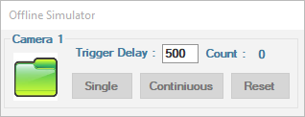

* + **Recipe Save, Retrieve, show, update and delete**
    - 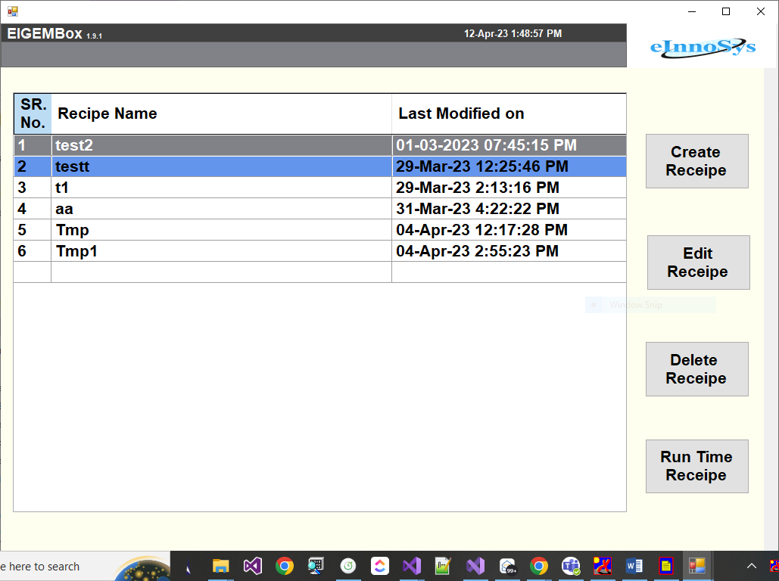There should be a feature where we will be able to save all the parameters of a batch. **EX.**  If I have the image of newspapers & also a book page. Then preprocessing parameters will be different from each other. If we won’t do it then every time we need to change all the parameters.
  + **Teaching Process**
    - There should be a ROI on a panel that is movable.
    - We should be able to crop the Image according to the ROI when teach or get data button pressed.
    - On clicking on teach data all the parameters that we have decided will be sent to our DLL which will process it further and return a string as an output.
    - Then need to call Post processing API that will do the further operation.

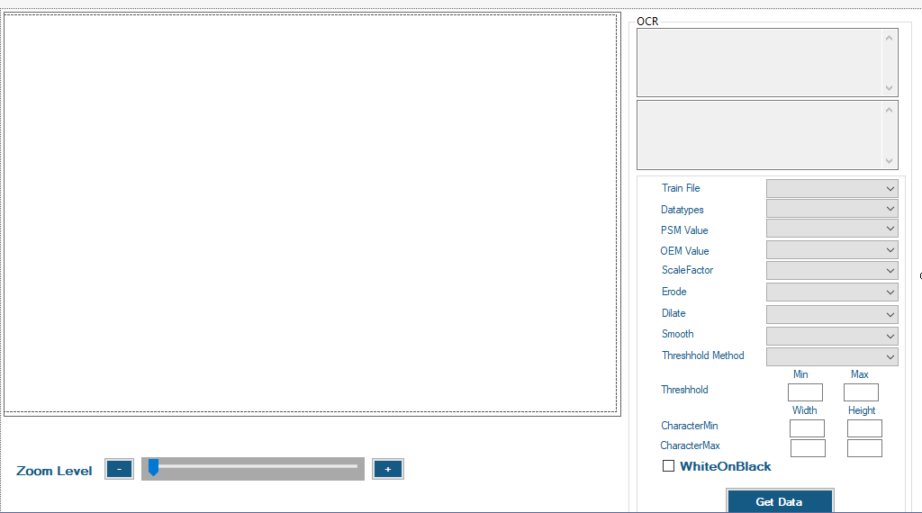

* + - There should be a save button that saves the recipe.
    - There should also be a feature where we can save the data to any specific file location.
* **OCR DLL**
  + **Preprocessing**
    - As per the selected parameters received on the preprocessing function, preprocessing will be done accordingly.
  + **Recognition**
    - The preprocessed image will be sent to Tesseract.
    - It will return a string.
  + **Post Processing**
    - The processed test will be sent to post processing function.
    - It will return the final string.

**Roles and responsibilities**

* **Ajay**
  + Provide the DLL with Preprocessing and Tesseract.
* **Jinoy**
  + Provide the DLL with Postprocessing.
* **Vadansh**
  + Provide UI with all API calling.